Chapter 11, Solution 3.

+
–
I

C
160∠0˚ R

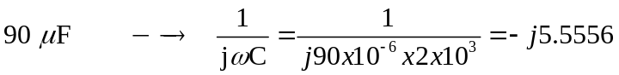

I = 160/60 = 2.667A

The average power delivered to the load is the same as the average power absorbed by the resistor which is

P_{avg} = 0.5|I|²60 = 213.4 W.

